Software Requirements Specification
for
<VIRTUAL CLASSROOM APPLICATION>
Version <X.X>

Prepared by
Group Name: Group 7
Greeshmanth Sai Y | CB.EN.U4CSE21170

Instructor: | Dr. Sabarish B. A.
Course: | 19CSE314-SOFTWARE ENGINEERING
Date: | 28-04-24

Table of Contents

Table of Contents ii
1 Introduction 1
1.1 Document Purpose 1
1.2 Product Scope 1
1.3 Definitions, Acronyms and Abbreviations 1
1.4 References and Acknowledgments 1
2 Overall Description 2
2.1 Product Functionality 2
2.2 End Users and Characteristics 2
2.3 System Stakeholders 2
2.4 Operating Environment 2
3 Specific Requirements 3
3.1 User Interface 3
3.2 Functional Requirements 3
3.3 Use Case Diagram 3
4 Non-functional Requirements 4
4.1 Software Quality Attributes 4
5 Other Requirements 5
Appendix A - Group Log 6

Introduction
This examines developing a virtual classroom application, aimed at meeting the increasing demand for online education platforms. The report supports the proposal for the creation of the virtual classroom application, outlining the necessity for such a platform, detailing the recommended project approach, and summarizing potential platforms under consideration by the project team.
With the ever-increasing popularity and accessibility of the Internet, it is only natural that the educational community should want to make use of this tremendous resource. Use of the Internet and Web are leading to significant changes in educational models. Effective exploitation of these changes requires adequate attention to understanding the technology, the educational processes and issues, student’s characteristics, etc.
The growing popularity of E-Learning has introduced new terms to education, as Virtual Classroom, where student will be present with his professor and fellow learners in a classroom. They will not be present physically in the classroom but connected to the classroom via Internet. Virtual classroom aims to simulate the experience of attending a class over the web. So, everyone is able to see another participant virtually.

The objectives of this document are to define the scope of the Virtual Classroom Application, outline specific requirements for each functionality, ensure usability and accessibility across devices and platforms, and establish a foundation for the development, deployment, and maintenance of the software solution. Through clear articulation of requirements and objectives, this document sets the direction for the development team to deliver a high-quality, user-friendly virtual classroom application that enhances the educational experience for all stakeholders involved.

Product Scope
- Video and audio conferencing: enabling real-time communication between participants.
- Interactive whiteboards and shared screens: facilitating collaborative learning activities and presentations.
- File sharing: allowing distribution of course materials, assignments, and other resources.
- Assessment tools: facilitating online quizzes, polls, and other forms of evaluation.
- Breakout rooms: enabling small group discussions and collaborative work.

Definitions, Acronyms and Abbreviations
- LMS - Learning Management System
- SRS - Software Requirements Specification

References and Acknowledgments
- The following documents and web resources are referenced in this Software Requirements Specification (SRS):

- User Interface Style Guide - A document outlining the design principles, visual elements, and interaction guidelines for the user interface of the Virtual Classroom Application.

- System Requirements Specification (SRS) - A comprehensive document detailing the overall requirements, features, and functionalities of the Virtual Classroom Application, serving as a reference for this document.

- Use Case Documents - Documents describing various scenarios and interactions between users and the Virtual Classroom Application, providing insights into user requirements and system behavior.

- These references contribute to the comprehensive understanding of the Virtual Classroom Application project and ensure alignment with user needs, industry standards, and project goals.

Overall Description

Product Functionality
The Virtual Classroom Application must facilitate the following major functions:

- Conduct live video conferencing sessions for real-time interaction between educators and learners.
- Enable seamless messaging and communication between users within the virtual classroom environment.
- Support content sharing capabilities, allowing educators to upload and share educational materials such as documents, presentations, and multimedia files.
- Provide interactive whiteboard functionality for collaborative brainstorming, problem-solving, and visual learning experiences.
- Track attendance of participants during virtual classroom sessions.
- Offer assessment tools for conducting quizzes, assignments, and exams within the virtual classroom platform.
- Ensure security and privacy of user data through robust authentication, encryption, and access control mechanisms.
- Allow customization and integration with external systems, such as Learning Management Systems (LMS) or content repositories, to enhance functionality and interoperability.

End Users and Characteristics

- Educators/Instructors:

Characteristics: Educators possess advanced technical skills and expertise in their subject matter. They are frequent users of the platform, requiring access to all features for content creation, delivery, and assessment.

- Students/Learners:

Characteristics: Students vary in technical proficiency and educational level. They frequently utilize the platform for attending classes, accessing course materials, participating in discussions, and completing assessments.

System Stakeholders

- Students: Primary users attending lectures and accessing resources.
- Instructors: Facilitators hosting classes and assessing performance.
- Administrators: Oversee system operation and manage settings.
- Technical Support: Provide assistance and troubleshoot issues.
- Developers: Design, develop, and maintain the system.
- Educational Institutions: Provide infrastructure and support.
- Parents/Guardians: Monitor children's progress.
- Regulatory Bodies: Define and enforce standards.

Operating Environment
The Virtual Classroom Application operates on various devices via web browsers, with minimum requirements including 4GB RAM for desktops and 2GB RAM for mobile devices. It is compatible with Windows 10+, macOS 10.13+, iOS 11+, and Android 7.0+. Major web browsers such as Google Chrome, Mozilla Firefox, Apple Safari, and Microsoft Edge are supported. The application relies on server-side infrastructure for hosting, user authentication, and real-time communication. It interacts with external components like databases and authentication services.

Specific Requirements

User Interface

The Virtual Classroom Application offers a user-friendly interface with the following key screens:
- Login: Users log in with credentials.
- Dashboard: Central hub for navigation.
- Classroom: Live sessions, content sharing.
- Content Library: Access course materials.
- Profile Settings: Manage account details

Functional Requirements
User Management:
- Registration and login.
- Password recovery and management.
- User role administration.
- Classroom Management:
- Scheduling and creation.
- Live video conferencing and messaging.
- Content sharing and interactive whiteboard.

Content Management:
- Upload and organization.
- Learner access.
- Version control.
- Assessment and Evaluation:
- Creation and administration of quizzes, assignments, and exams.
- Automated grading and performance tracking.

Administrative Tools:

- System settings and configurations.
- Usage statistics and reports.
- User account administration.

Integration and Customization:
- Integration with external systems.
- Customization options for branding and theming.
- Third-party tool integration.

Use Case Diagram
A use case diagram represents the interactions between external actors and the Virtual Classroom Application.

Actors:
- Educator: A user who conducts classes and manages course materials.
- Student: A user who attends classes and accesses course materials.
- Administrator: A user who manages system settings and user accounts.
- Technical Support: A user who provides assistance with technical issues.

Use Cases:
- Schedule Class: Educator schedules a class.
- Attend Class: Student attends a class.
- Manage Content: Educator uploads and manages course materials.
- Manage User Accounts: Administrator manages user accounts.
- Provide Technical Support: Technical Support assists users with technical issues.
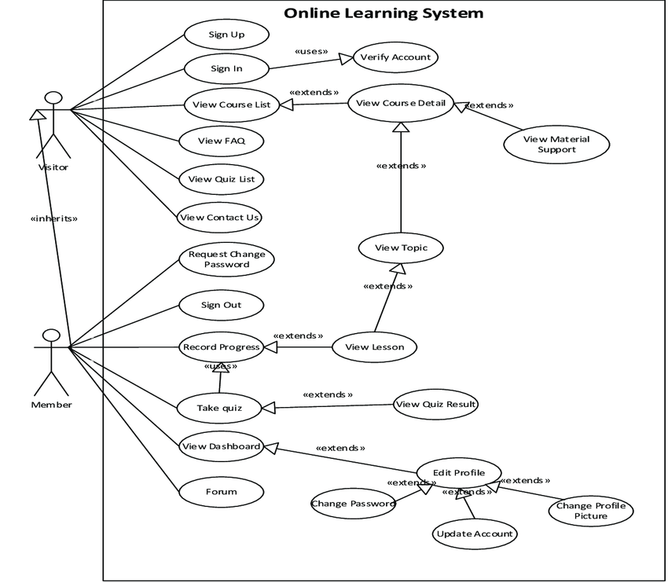

Non-functional Requirements

Software Quality Attributes
- Usability: Ensure intuitive navigation and user-friendly interface.
- Reliability: Maintain high system uptime and minimize downtime.
- Security: Implement robust authentication and encryption measures to protect user data.
- Performance: Optimize for fast loading times and smooth operation.
- Maintainability: Design codebase for easy maintenance and updates.
- Interoperability: Ensure compatibility with various devices and platforms.
- Scalability: Ability to handle increasing numbers of users and data without degradation in performance.
- Testability: Design for easy testing and validation of system functionality.

Other Requirements
- Database: Specify DBMS, schema, and backup.
- Internationalization: Address language and compliance.
- Legal: Outline regulations and licensing.
- Reuse: Define code reuse and third-party components.
- Security: Specify authentication, encryption, and protection.
- Performance: Define response time, scalability, and optimization.
- Reliability: Specify uptime and fault tolerance.
- Documentation: Define user manuals and training.
- Maintenance: Address bug fixes and support channels.

Appendix A - Group Log

Group Meetings Minutes:
- Discussed the scope and objectives of the virtual classroom application.
- Brainstormed features including video conferencing, chat, file sharing, and attendance tracking.
- Assigned tasks to team members for researching similar platforms, defining user roles, and drafting use cases.
Group Activities:
- Conducted research on virtual classroom platforms to gather insights into best practices and functionalities.
- Collaborated on defining user stories and use cases to capture the requirements of different stakeholders.
- Held regular review sessions to consolidate individual contributions and ensure alignment with project goals.
Relevant Information:
- Identified key stakeholders including students, instructors, administrators, and IT support staff.
- Agreed upon technology stack including video streaming APIs, chat libraries, and database systems.
- Outlined security measures such as end-to-end encryption and user authentication mechanisms.
- Addressed scalability concerns by considering cloud hosting options and load balancing strategies.

